**PROJECT REPORT**

**Project Title:**

EduTutor AI**:** Personalized Learning with Generative AI and

LMS Integration

**Team ID:**

LTVIP2025TMID32928

**Submitted by :**

**1.**Md Irfan(Team Leader)

**2.**Gowru Sujitha

**3.**Kandati Vandana

**4.**Damera Sai Sreeja

**Institution:**

Sri Venkateshwara College Of Engineering Dept.of CSE

**Submitted to:**

Smartinterz – Generative AI with IBM Cloud

Virtual Internship Program 2025

INTRODUCTION

# 1.1 Overview

*EduTutor AI is a lightweight, AI-powered learning assistant developed to enhance student education through personalized content generation. Designed with simplicity and accessibility in mind, the system uses IBM’s Watsonx Granite large language models (LLMs) to provide interactive learning experiences directly through a FastAPI backend.*

*The platform enables students to:*

* *Understand academic topics through natural language explanations.*
* *Generate custom quizzes from text input or uploaded PDF materials.*
* *Practice English or Hindi grammar and vocabulary interactively.*

*Unlike traditional tutoring systems or static e-learning platforms, EduTutor AI uses prompt-based interactions with a generative model to create on-demand educational content tailored to each user's input. The application does not depend on third-party libraries like Hugging Face; instead, it connects directly to IBM Watsonx APIs, offering a secure and scalable deployment route.*

*With modules for concept understanding, automated assessment, and bilingual language support,*

*EduTutor AI brings together modern AI capabilities to deliver a more engaging and personalized student learning experience.*

# *1.2 Purpose*

*ThepurposeofEduTutor AI is to bridge the gap between traditional teaching methods and modern AIbased educational tools. The key goals of the system are:*

* *To assist students in learning complex topics by generating simple and accurate explanations.*
* *To enable automated quiz creation from both typed topics and uploaded study material in PDF form, saving time and ensuring consistent practice.*
* *To provide interactive English and Hindi language learning support, including grammar correction and vocabulary improvement.*

*By integrating IBM’s enterprise-grade LLMs into a focused educational assistant, EduTutor AI aims to make quality tutoring and self-paced assessment tools accessible to all learners—especially in resource-constrained or bilingual environments.*

## **2. Ideation Phase 2.1 Define the Problem Statements**



Date

Team ID

Project Name

Maximum Marks

26

June

2025

LTVIP2025TMID32928

EduTutor AI: Personalized Learning with

Generative AI and LMS Integration

2

Marks

**Customer Problem Statement EduTutor AI:**

In today’s fast-paced education system, students often face the challenge of understanding complex subjects without proper guidance. Many rely on online resources, but these are often generic, not personalized to the learner’s pace or style. Meanwhile, educators are overwhelmed with the repetitive task of creating and evaluating quizzes manually for every student.

EduTutor AI aims to solve this by offering a personalized AI tutor that provides:

* Concept explanations simplified for different age levels
* Grammar and language learning support in English and Hindi

•

Automated quiz and test generation from PDFs and topics

This solution empowers students to learn at their own pace with clarity,and enables educators to scale personalizedlearning experiences without increased workload.

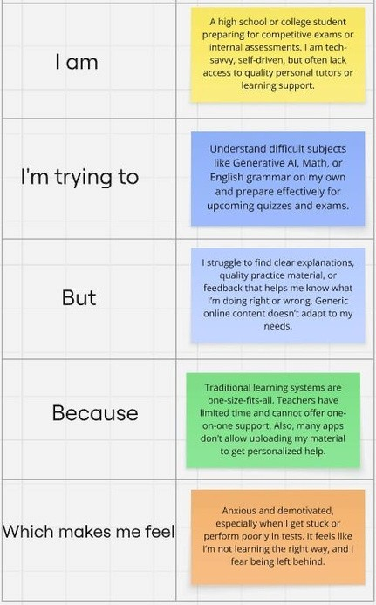

**Example:**

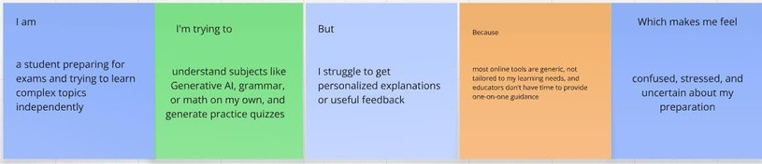



PS-2

**Problem**

**Statement (PS)**

PS-1

a teacher

managing

multiple

students

**I**

**am**

**(**

**Customer**

**)**

a high

school

student

preparing

for exams

generate

personalized

**I’m trying to**

understand

difficult topics

and revise

efficiently

**But**

**Because**

**Which makes me feel**

I can't

grasp the

concepts

fully and

get no

feedback

online

resources are

generic and

teachers are

not always

available

frustrated, confused,

and unsupported

I don’t

have time creation and

review takes

too much

effort

manual

overwhelmed and

limited in my teaching

impact

to

prepare

and

evaluate

tests for

each

student

## **2 Ideation Phase**

**2.2Brainstorm & IdeaPrioritization Template**



Date

Team ID

Project Name

Maximum Marks

26

June

2025

LTVIP2025TMID32928

EduTutor AI: Personalized Learning with

Generative AI and LMS Integration

4

Marks

**Brainstorm & IdeaPrioritization EduTutor AI:** Brainstorming provides a free and open environment that encourages everyone within a team

to participate in the creative thinking process that leads to problem solving. Prioritizing volume over value, out-of-the-box ideas are welcome and built upon, and all participants are encouraged to collaborate, helping each other develop a rich amount of creative solutions.

### Step-1: Team Gathering, Collaboration and Select the Problem Statement

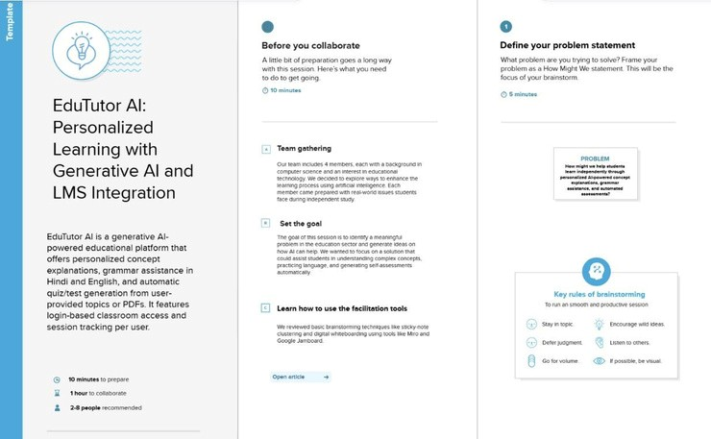

**Step-2: Brainstorm, Idea Listing and Grouping**

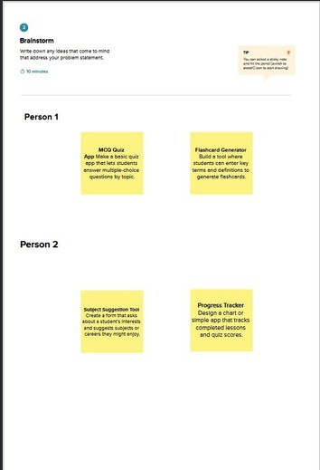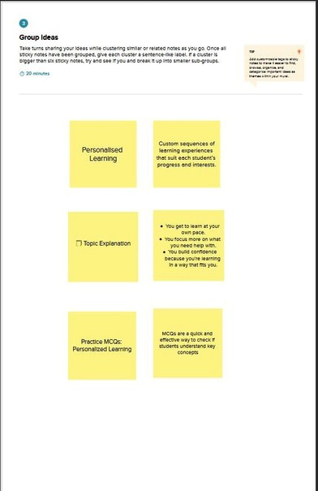

**Step-3: Idea Prioritization**

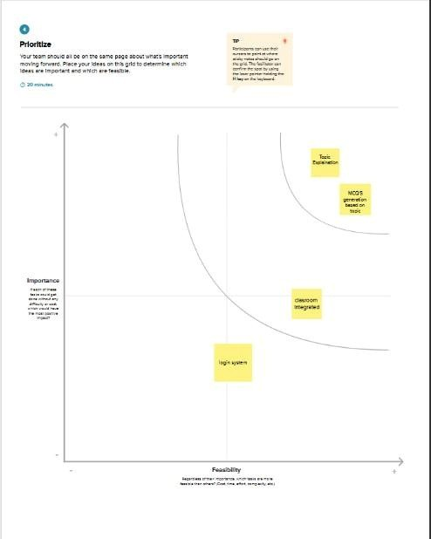

1. **Ideation Phase**



Date

Team ID

Project Name

Maximum Marks

26

June

2 025

LTVIP2025TMID32928

EduTutor AI: Personalized Learning with

Generative AI and LMSIntegration

4

Marks

**2.3 Empathize & Discover**

**Empathy Map Canvas EduTutor AI:**

# 🟦 SAYS

What the student/user verbally expresses:

* “I don’t understand this topic, even after watching videos.”
* “I need a simple explanation like a teacher would give.”
* “I wish I could practice more questions like in school.”

# 🟦 THINKS

What the user is thinking but might not say out loud:

* “Am I studying the right way?”
* “What if I fail the test because I missed something important?”
* “Other students probably have better help than I do.”

# 🟦 DOES

What actions or behaviors the student takes:

* Searches YouTube or websites for topics
* Uploads books or PDFs to extract questions

•

Tries apps for grammar and test prep

* Attempts mock tests but gets no explanations

# 🟦 FEELS

What emotions the user experiences:

* Anxious and overwhelmed before exams
* Relieved when they finally understand a topic
* Disappointed by one-size-fits-all apps
* Excited when learning becomes personalized **Example:**

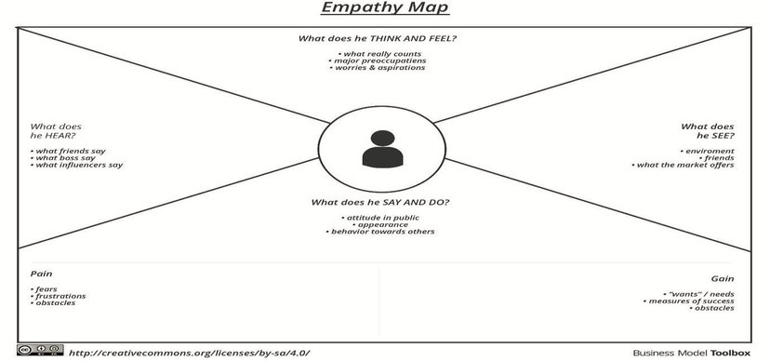

# Example: EduTutor AI

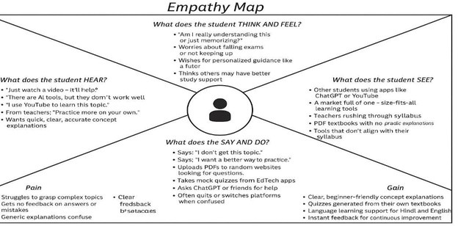

**3. Requirement Analysis**

## **3.1 Solution Requirements (Functional & Non-functional)**



Date

Team ID

Project Name

27

June

2025

LTVIP2025TMID32928

EduTutor AI: Personalized Learning with

Generative AI and LMS Integration

4

Marks

Maximum Marks

# Functional Requirements

*Thefollowingare thecore functionalrequirements for the EduTutor AI application, based strictly on the current feature set outlined in the README.*



FR No.

Functional Requirement

(

Epic

)

User Input Handling

Sub Requirement (Story /

Sub-Task)

Accept topic input from

user through a text field

Send topic to IBM

Watsonx model Display

explanation using

Streamlit

Generate multiple-choice

questions (MCQs) from

the given topic

Display MCQs with

correct answers

Allow user to enter IBM

Watsonx API key and

project ID in app.py

FR-1

FR-2

Explanation Generation

FR-3

MCQ Generation

FR-4

Credential Configuration

# Non-Functional Requirements

The following are the non-functional requirements for the current version of EduTutor AI.



NFR-2

NFR-3

NFR-4

NFR-5

NFR No.

NFR-1

Security

Reliability

Performance

Non-Functional

Requirement

Usability

Deployment Simplicity

Description

The Streamlit interface

should be simple and

intuitive for quick

interaction.

IBM Watsonx credentials

should be kept secure and

not hard-coded for public

use.

System should consistently

produce valid explanations

and MCQs for well-formed

inputs.

Output should be

generated within 2–4

seconds under normal load.

App should run with

minimal setup using

'streamlit run app.py'.

## **3. Requirement Analysis 3.2 Data Flow Diagram & User Stories**



Date

Team ID

Project Name

Maximum Marks

27

June

2025

LTVIP2025TMID32928

EduTutor AI: Personalized Learning with

Generative AI and LMS Integration

4

Marks

**Data Flow Diagrams:**

A Data Flow Diagram (DFD) is a traditional visual representation of the information flows within a system. A neat and clear DFD can depict the right amount of the system requirement graphically. It shows how data enters and leaves the system, what changes the information, and where data is stored.

A **Data Flow Diagram (DFD)** is a graphical tool used to model the flow of data within a system. It shows how data is **input, processed, stored, and output** in a clear and systematic way. For EduTutor AI, the DFD outlines how users interact with the system through the interface and how their data is processed by the AI model and other components.

**Example:** [**(Simplified)**](https://developer.ibm.com/patterns/visualize-unstructured-text/)



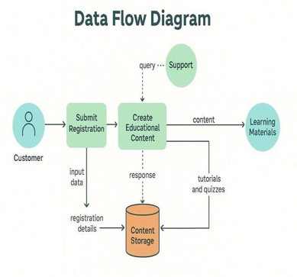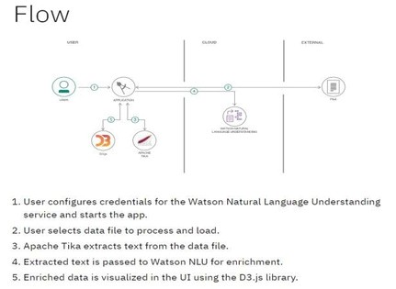

DFDo f EduTuto r

# User Stories

Usethebelowtemplateto list all the user stories for the product.



**User Type**

**Customer**

**(**

**Mobile**

**user)**

**Functional**

**Requirement Story**

**User**

**Acceptance**

**Criteria**

**User Story / Task**

**Priority**

**Release**

**(**

**Epic**

**)**

**Number**

As a user, I can register for the I can access my

Streamlit UI

USN-1

application by entering my

name and password

As a user, I can log into the

application using name &

password.

account/dashboard High

Sprint-1

Login should

redirect me to the

dashboard

USN-2

High

Sprint-1

Concept

Explanation

As a user, I can enter a concept The concept is

USN-3

and

explanation.

As a user, I can enter atopic it

generates questions for

practice.

As a user, I can choose a

language

(

English/Hindi) to learn

grammar and parts of speech.

get

a

simplified clearly explained in High

Sprint-1

an easy way

A quiz with

relevant questions

is generated

Language learning

content is

displayed

MCQ

Generation

USN-4

High

Sprint-2

USN-5

Medium Sprint-2

**3. Requirement Analysis**

**3.3Technology Stack (Architecture & Stack)**



Date

Team ID

Project Name

Maximum Marks

4

Marks

27

June

2025

LTVIP2025TMID32928

EduTutor AI: Personalized Learning with Generative

AI and LMS Integration

# **Architecture Layers & Flow**



External Interfaces

Layer

User Interface Layer

(

Local

)

Application Logic Layer

Local

)

(

AI Model Layer (Cloud)

Data Storage Layer (Local)

Python

Technology

Streamlit

IBM Watsonx API

Credentials

In-memory Dictionary

)

Python

(

IBM Watsonx via ibm-

watsonx-ai SDK

Secure communication

with IBM foundation

model APIs

Handles prompt

generation, session

management, and quiz

formatting logic

Uses Granite model

granite-3-8b-instruct) to

(

generate topic

explanations and MCQs

Temporarily stores session

data and results during

runtime

Description

Collects user input such as

concept/topic; displays

explanations and MCQs

**Table 1: Components & Technologies**



4

5

Availability

Performance

Run locally or deploy on

Hugging Face Spaces or

Streamlit Cloud

Fast text generation via

optimized cloud APIs

IBM Watsonx optimized

models

Python + Streamlit Cloud

3

S.no

1

2

Scalability

Characteristic

Open-Source Frameworks

Security Implementations

Description

Built using open tools

Credentials stored securely

locally or in Hugging Face

(

secrets)

Modular layers (UI → Logic

→Model); extendable

Streamlit + API-based logic

Technology

Streamlit, Python, IBM SDK

API Key + Project ID



2

3

4

5

6

S.No

1

External API

Component

User Interface

Session Handling

Application Logic

Machine Learning Model

Infrastructure

Description Interactive UI for

input and

output display

Prompt construction, logic

output handling

Tracks user inputs/output

per session

Accesses IBM Watsonx

foundation model

Performs natural language

generation

Execution environment for

app

Python

Technology

Streamlit

Python in-memory

structures

IBM Watsonx AI SDK (ibm-

watsonx-ai)

granite-3-8b-instruct

Local Runtime / Cloud-

hosted via Hugging Face

Spaces

**Table 2: Application Characteristics**

•

1. **Project Design**

**4.1 Problem – Solution Fit Template**



Date

Team ID

Project Name

Maximum Marks

27

June

2025

LTVIP2025TMID32928

EduTutor AI: Personalized Learning with

Generative AI and LMS Integration

2

Marks

**Problem – Solution Fit EduTutor AI:**

## **Problem**

Many students struggle to understand complex academic concepts on their own and lack the ability to assess their knowledge effectively. Despite the abundance of content online, these materials are often generic, not tailored to individual learning styles, languages, or needs. Simultaneously, educators lack tools to personalize instruction or quickly generate and evaluate assessments for each student. This gap leads to confusion, low confidence, poor academic performance, and overburdened educators.

## **Solution**

**EduTutor AI** is a personalized learning platform that uses generative AI to explain concepts in a simplified manner, offer grammar assistance (in Hindi and English), and automatically generate quizzes and tests from topics or uploaded PDFs. It includes:

* Concept explanations tuned for age and subject level
* MCQ’S generators

This solution directly addresses students' needs for clarity, practice — while reducing effort for educators in content preparation.

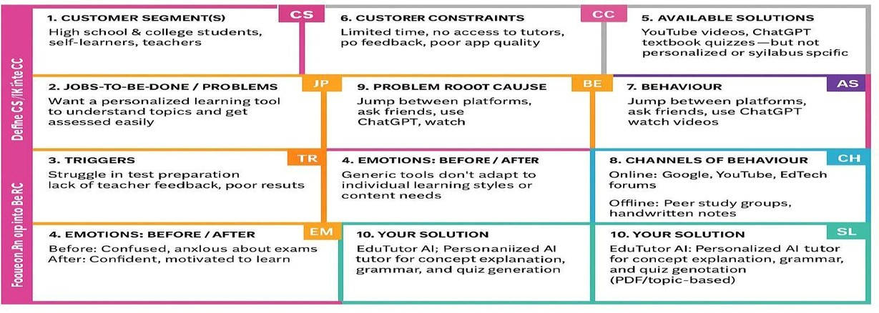

**4. Project Design Phase**

**4.2 Proposed Solution Template**



Date

Team ID

Project Name

Maximum Marks

27

June

2025

LTVIP2025TMID32928

EduTutor AI: Personalized Learning with

Generative AI and LMS Integration

2

Marks

**Proposed Solution EduTutor AI:**

Project team shall fill the following information in the proposed solution template.

**S.No. Parameter Description**

1. Problem Statement (Problem to be solved)

Students face difficulties in understanding complex topics independently and lack access to

1. Idea / Solution description
2. Novelty / Uniqueness
3. Social Impact / Customer Satisfaction
4. Business Model (Revenue Model)
5. Scalability of the Solution personalized learning . Teachers also struggle with time-consuming quiz generation and individual evaluation.

EduTutor AI is a generative AI-powered educational platform that offers personalized concept explanations, grammar assistance in Hindi and English, and MCQ’S generation from user-provided topics . It features login-based classroom access and session tracking per user. Unlike generic platforms, EduTutor AI can offer desirable explanation and generate personalized quizzes. It combines LMS features with generative AI for both concept delivery and adaptive assessment in multiple languages.

It enhances accessibility to quality education for students without tutors, supports regional languages, and reduces the workload on teachers. Students gain confidence and clarity, while teachers benefit from automation.

Freemium model: free access to basic features (concepts, quizzes), with premium plans for advanced features like PDF uploads, progress analytics, custom LMS integration for schools/colleges. Additional revenue through institutional licensing.

The solution is cloud-based and can support millions of users with the same backend. It can scale across languages, educational levels, and institutions globally, and easily integrate with other EdTech platforms or LMS providers.

1. **Project Design Phase**

**4.3 SolutionArchitecture**



Date

Team ID

Project Name

2

7 June

2025

LTVIP2025TMID32928

EduTutor AI: Personalized Learning with

Generative AI and LMS Integration

4

Marks

Maximum Marks

## Solution Architecture

Solution architectureoutlines howthesystem components are organized to achieve the project’s functional goals. It bridges the gap between business requirements and technical implementation in a structured and scalable way.

Purpose

EduTutor AI is designed to offer a personalized learning experience using generative AI capabilities provided by IBM Watsonx. The platform provides users with the ability to input a topic and receive either a clear explanation or a set of quiz questions. The entire application is built using Python and Streamlit, without any complex backend frameworks or third-party language model integrations such as Hugging Face.

Architecture Overview

The system architecture is composed of three primary layers:

1. User Interface Layer (Streamlit)

This layer is responsible for interacting with the user through a web-based UI built entirely in Streamlit. It provides:

* + A text input field for entering concepts or topics

•

A mode selector to switch between "Explain" and "Quiz"

•

A display area to show either the explanation or the generated quiz

•

A simple, responsive interface that runs locally or in the cloud

1. Logic & Processing Layer (Python)

This layer contains the core application logic, which includes:

* + Handling user input and selection of modes
  + Formatting prompts for explanation or quiz generation

•

Managing user session data using Python dictionaries (if applicable)

•

Communicating with the IBM Watsonx API

•

Optionally handling file input and parsing via PyPDF2 (for PDF-to-quiz functionality)

1. AI Model Layer (IBM Watsonx Granite API)

This layer integrates directly with IBM Watsonx, utilizing the Granite 3.3-2B-Instruct model via secure API calls. It performs:

* + Concept explanation generation based on natural language input

•

Topic-based quiz generation (5 MCQs with options and correct answers)

•

Language-specific responses when needed (e.g., English/Hindi grammar lessons) Data Flow Summary

* 1. The user interacts with the Streamlit interface to enter a concept or topic.
  2. The Python backend detects the selected mode (Explain or Quiz) and prepares the appropriate prompt.
  3. The prompt is sent to the IBM Watsonx API using the provided credentials.
  4. The AI model processes the input and returns a response.
  5. The response is formatted and displayed to the user in the Streamlit interface.

**Example - Solution Architecture Diagram:**

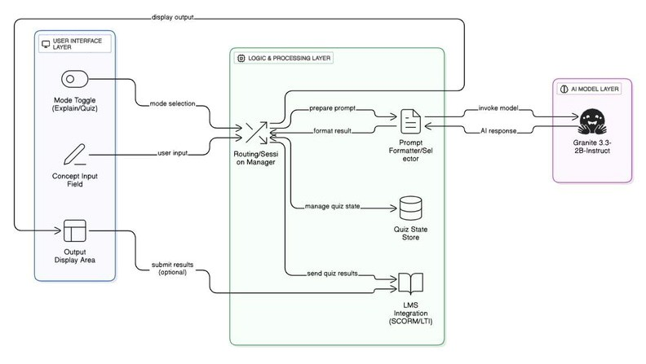

*ure 1: Architecture and data flow of the*

*EduTutor AI: Personalized Learning*

### 5. Project Planning Phase

**5.1ProjectPlanningTemplate (ProdBacklog, Sprint Planning, Stories, Story points)**



Date

Team ID

Project Name

Maximum Marks

5

Marks

27

June

2025

LTVIP2025TMID32928

EduTutor AI: Personalized Learning with Generative

AIandLMS Integration

**Product Backlog, Sprint Schedule, and Estimation (4 Marks)**

Use the below template to create product backlog and sprint schedule



**Sprint**

**Sprint-1**

**Sprint-1**

**Sprint-1**

**Sprint-2**

**Sprint-2**

**Sprint-3**

**Sprint-3**

**Sprint-3**

**Functional**

**Requirement**

**(**

**Epic**

**)**

Streamlit UI

**USN-2**

**USN-3**

**USN-4**

**USN-5**

**USN-6**

**USN-7**

**USN-8**

**User**

**Story**

**Number**

**USN-1**

**User Story / Task**

**Story**

**Points**

**As a user, I can register using a**

**username**

**2**

**andpassword.**

**As a user, I can log in to my**

**account with name and**

**password.**

**As a user, I can track my**

**2**

**sessions**

**2**

**after login.**

**As a user, I can enter a concept**

**AIgenerated**

**and**

**get**

**3**

**explanation.**

**As a user, I can choose Hindi or**

**English and learn grammar**

**basics.**

**As a user, I can upload a PDF**

**and receive a quiz based on the**

**content.**

**As a user, I can enter a topic**

**and receive a custom quiz.**

**As a developer, I can create a**

**3**

**5**

**3**

**multi-tab**

**3**

**UIusing Gradio.**

**High**

**High**

**High**

**High**

**High**

**Medium**

**Medium**

**High**

**Priority**

**varsh a**

**varsh a**

**nazima**

**nazima**

**nazima**

**Team**

**Members**

**varsh a**

**,nazima**

**varsh a**

Output

Formatting

Mode Switching

Logic

MCQ

Generator

Prompting

Answer

Formatting

Watsonx

Integration

Streamlit

Deployment

Error Handling

**varsha**

Imagine we have a 5-day sprint duration, and the velocity of the team is 13 (points per sprint). Let’s calculate the team’s average velocity (AV) per iteration unit (story points per day)

AV = sprint duration / velocity = 13 / 5 = 2.6

**Burndown Chart:**

A burn [down chart is a graphical](https://www.visual-paradigm.com/scrum/what-is-agile-software-development/) representation of wo[rk left to d](https://www.visual-paradigm.com/scrum/scrum-in-3-minutes/)o versus time. It is often used in agil[e software development m](https://www.visual-paradigm.com/scrum/what-is-agile-software-development/)ethodologies such a[s Scrum.](https://www.visual-paradigm.com/scrum/scrum-in-3-minutes/) However, burn down charts can be applied to any project containing measurable progress over time.



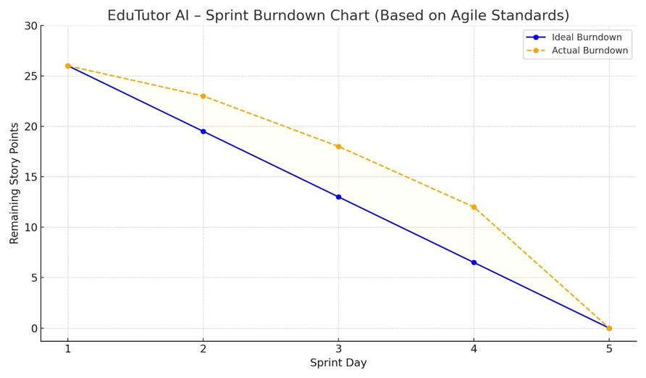

[**https://www.visual-paradigm.com/scrum/scrum-burndown-chart/**](https://www.visual-paradigm.com/scrum/scrum-burndown-chart/) [**https://www.atlassian.com/agile/tutorials/burndow** **n** **-** **chart** **s**](https://www.atlassian.com/agile/tutorials/burndown-charts)

## 6.RESULTS

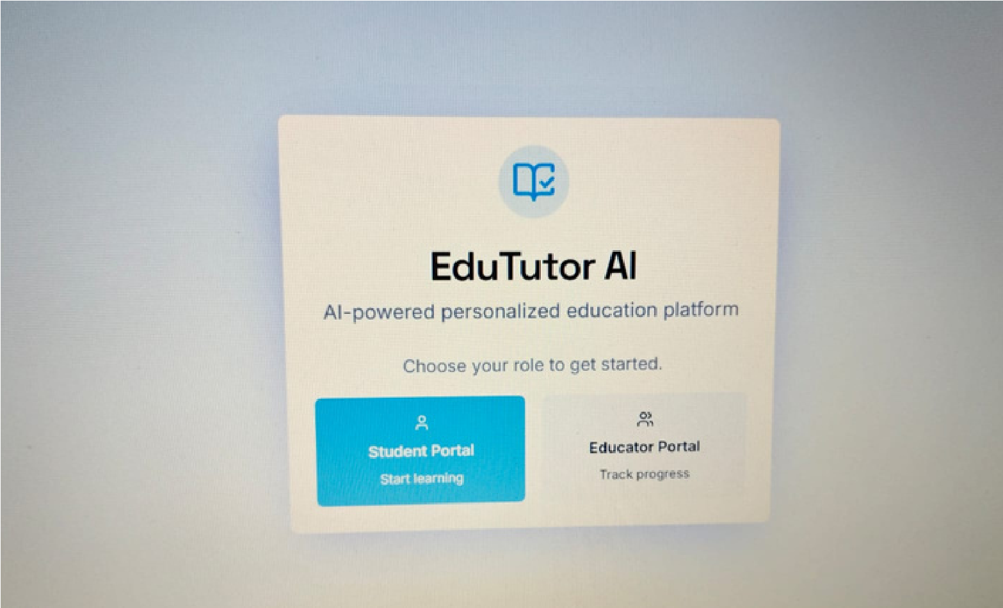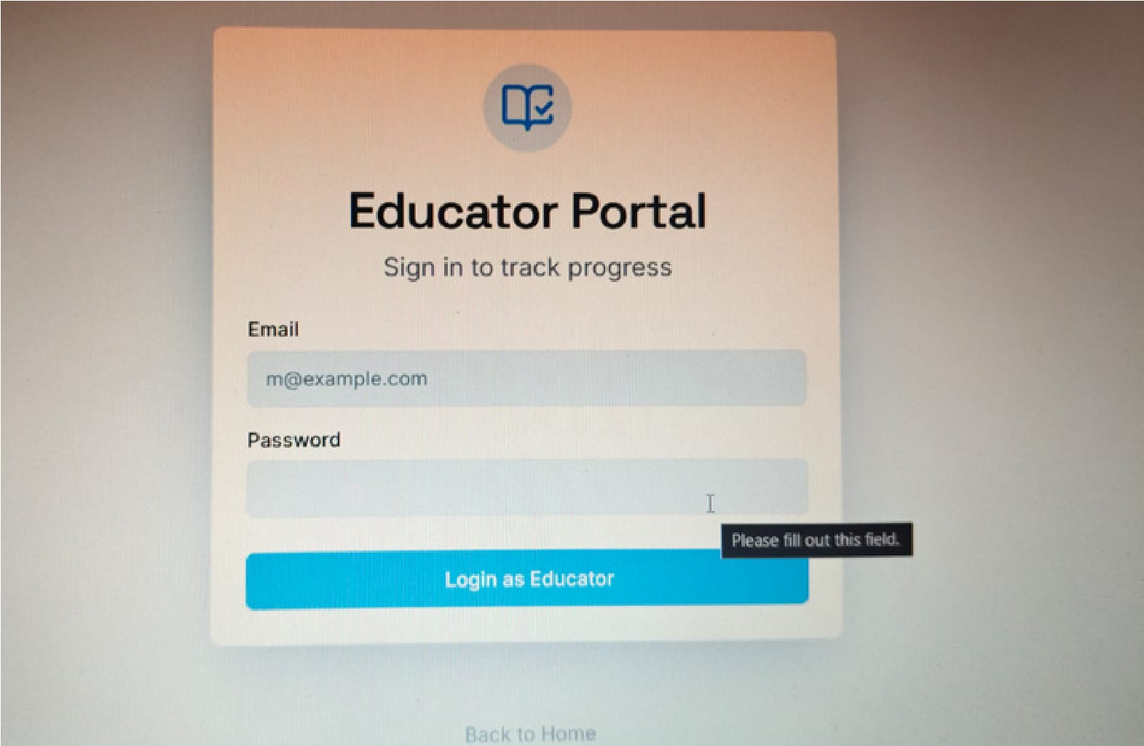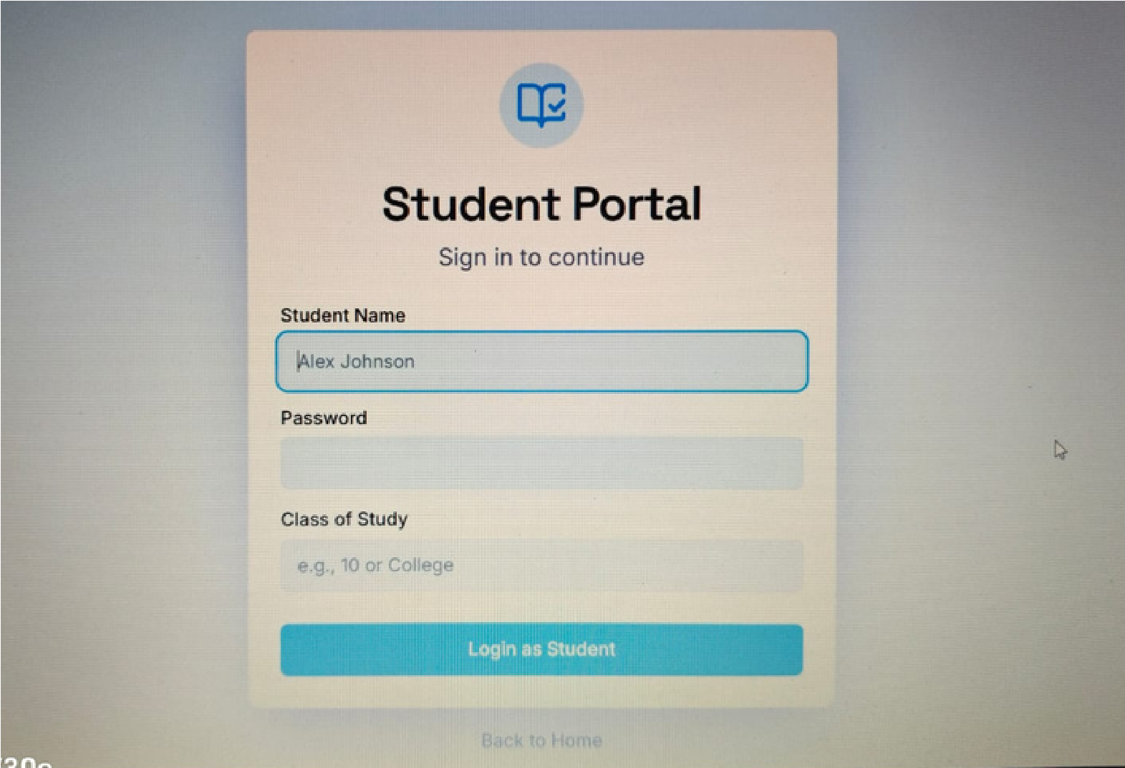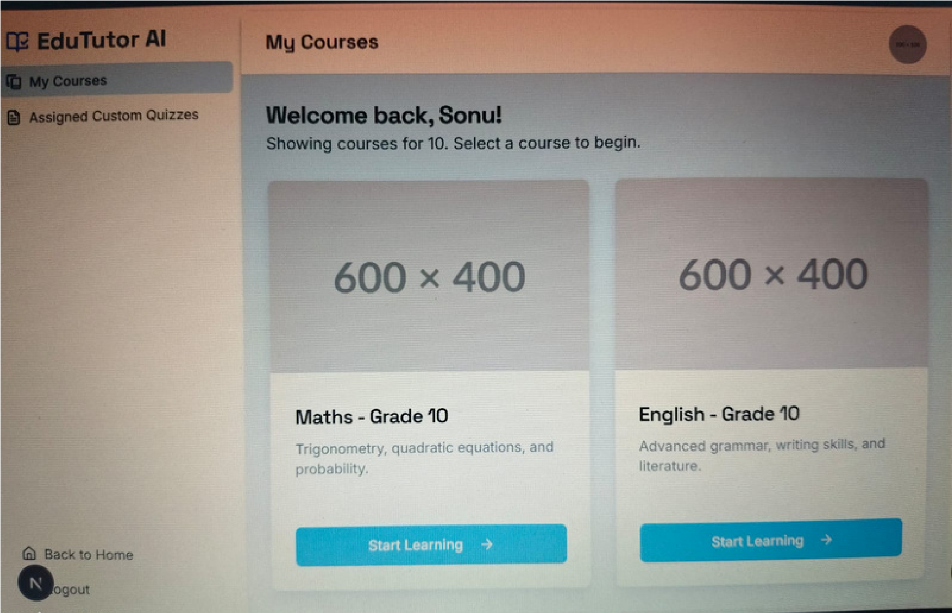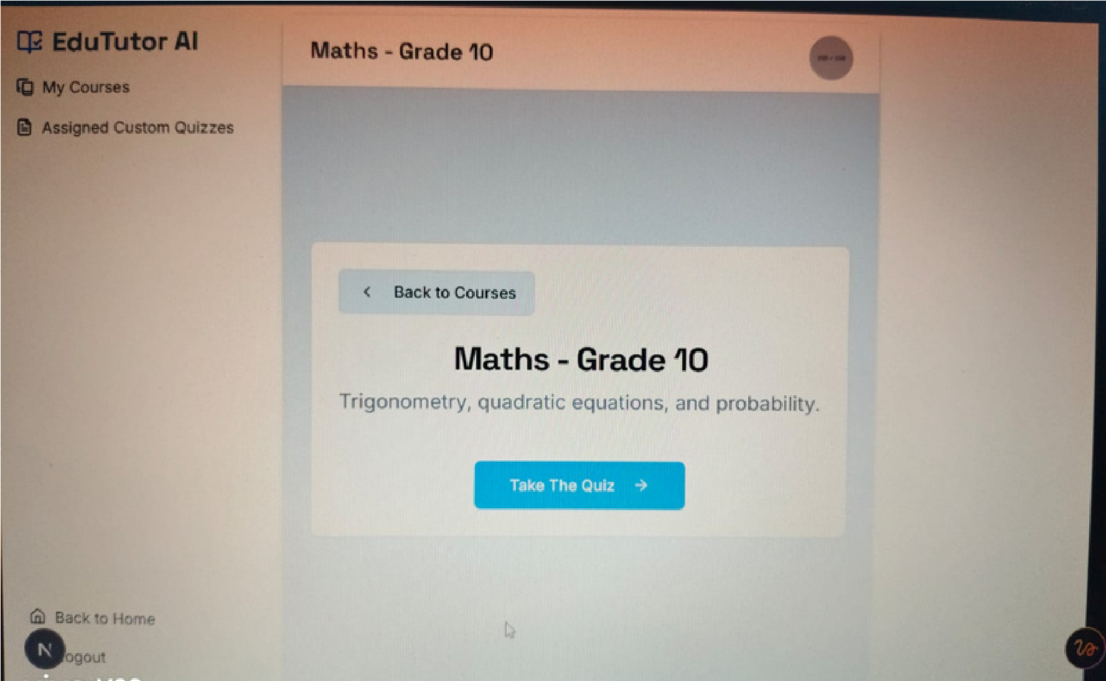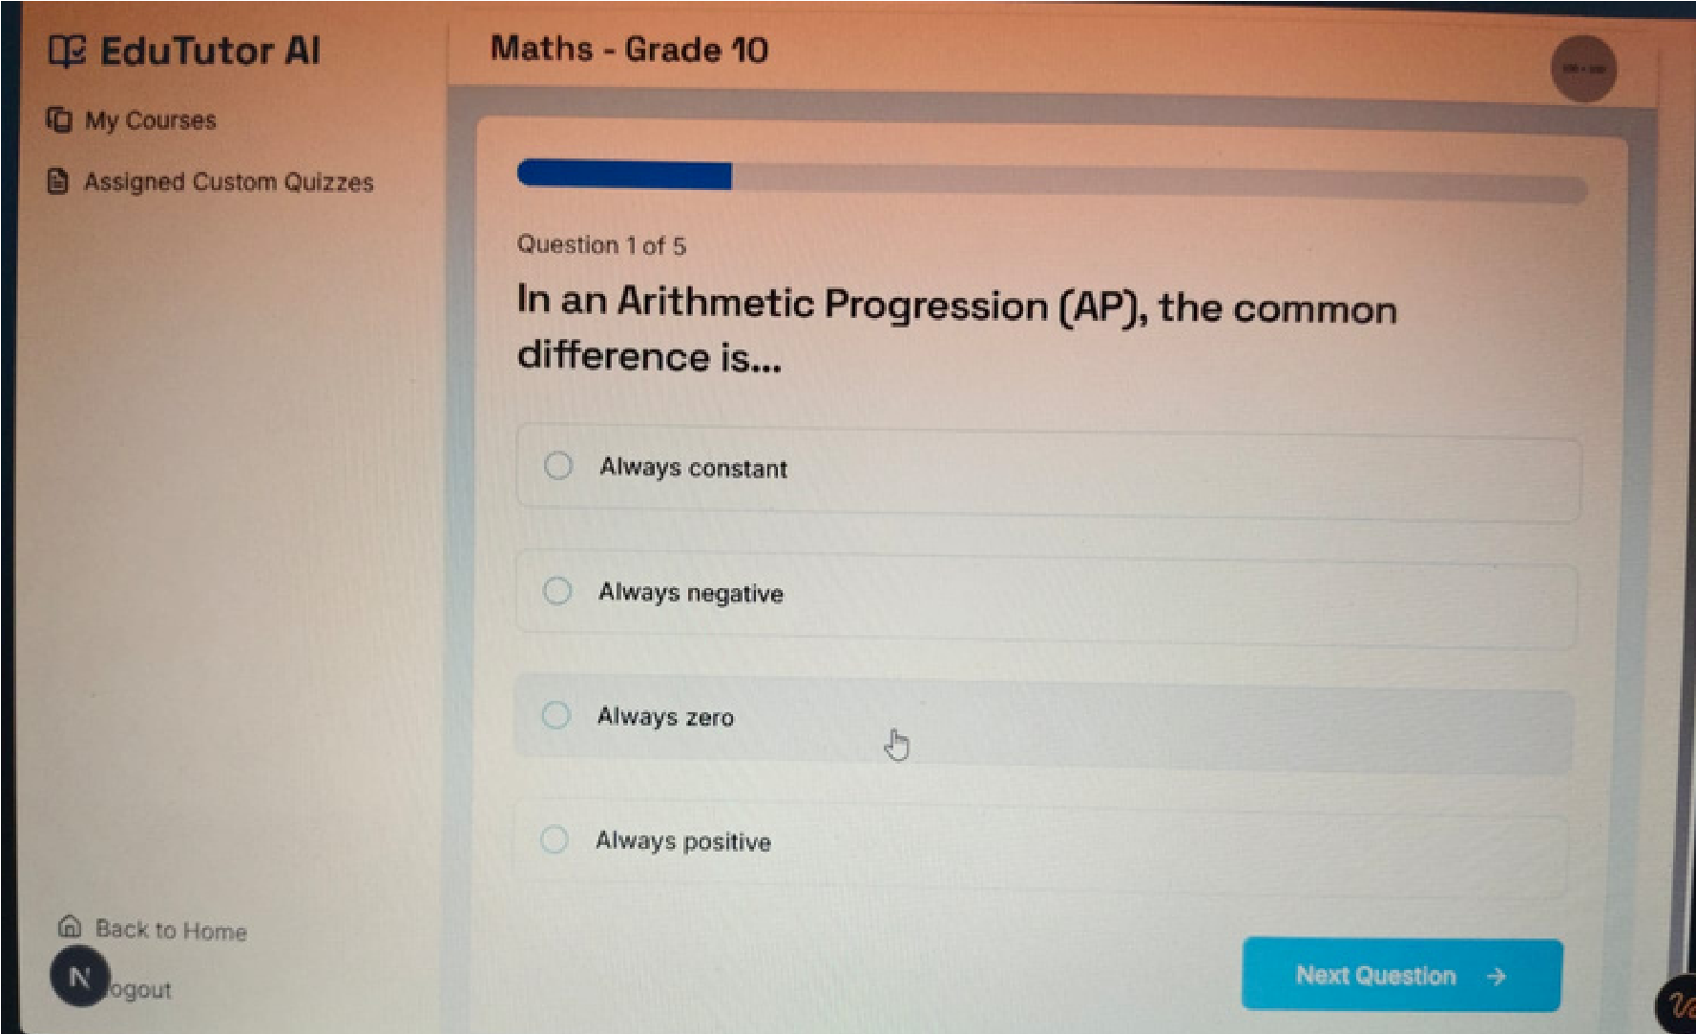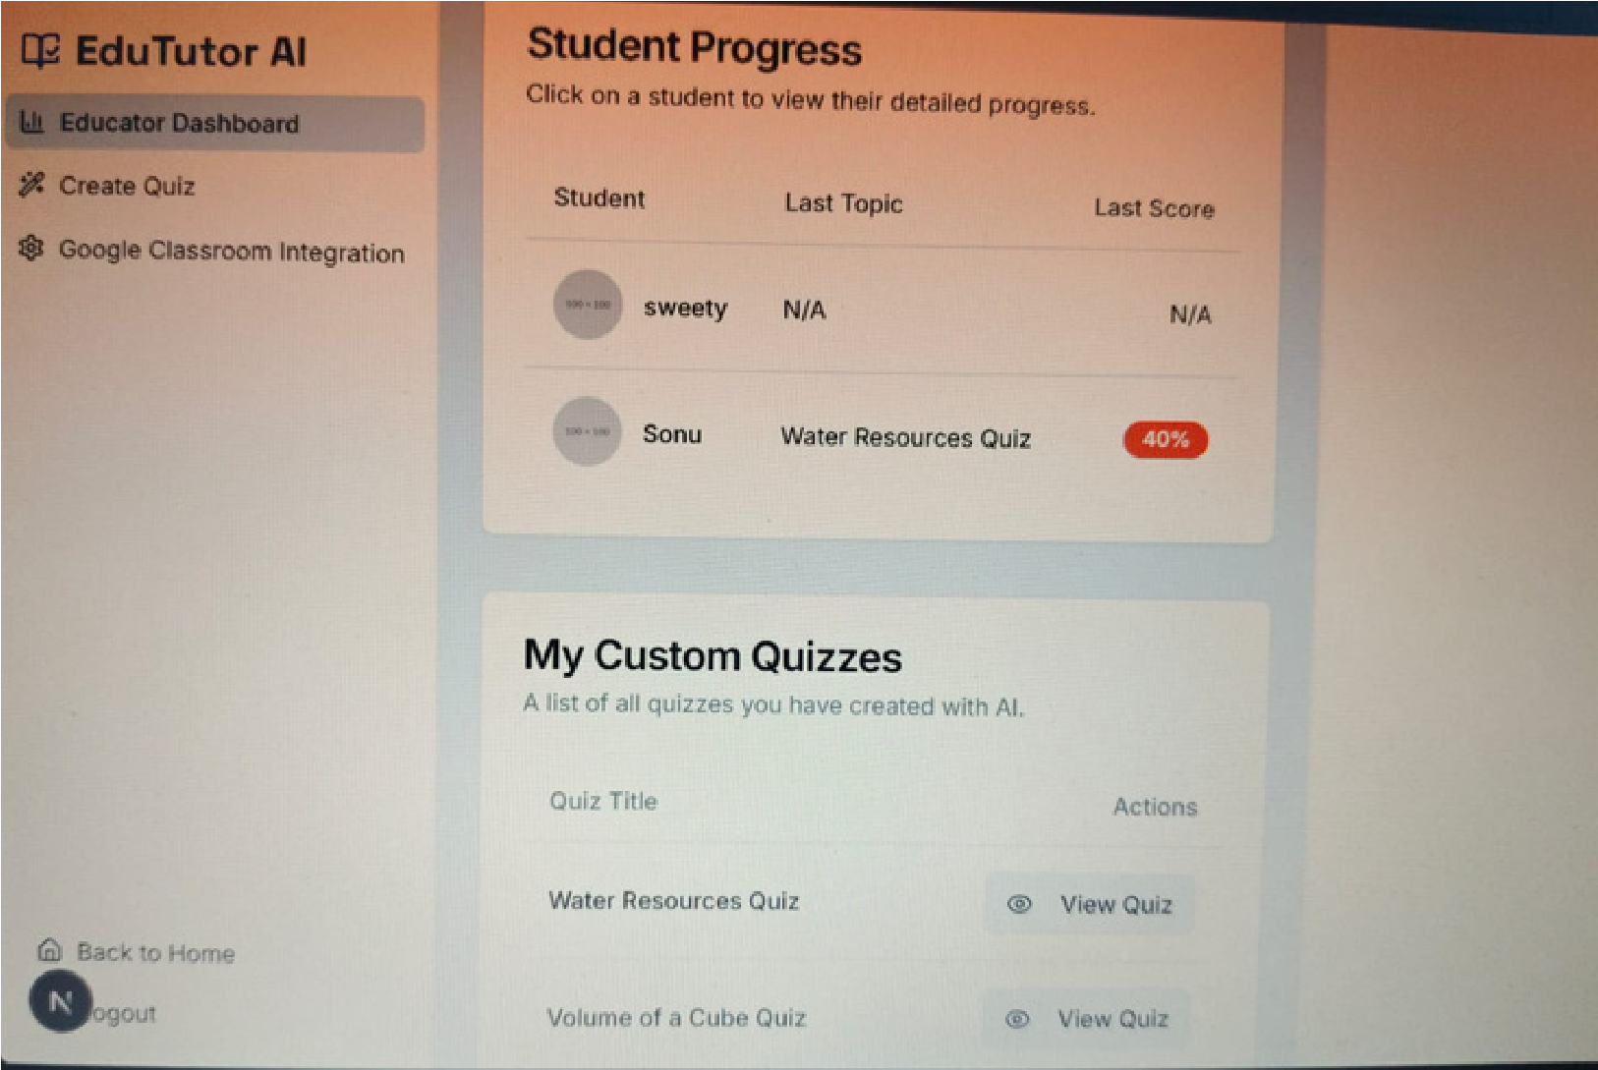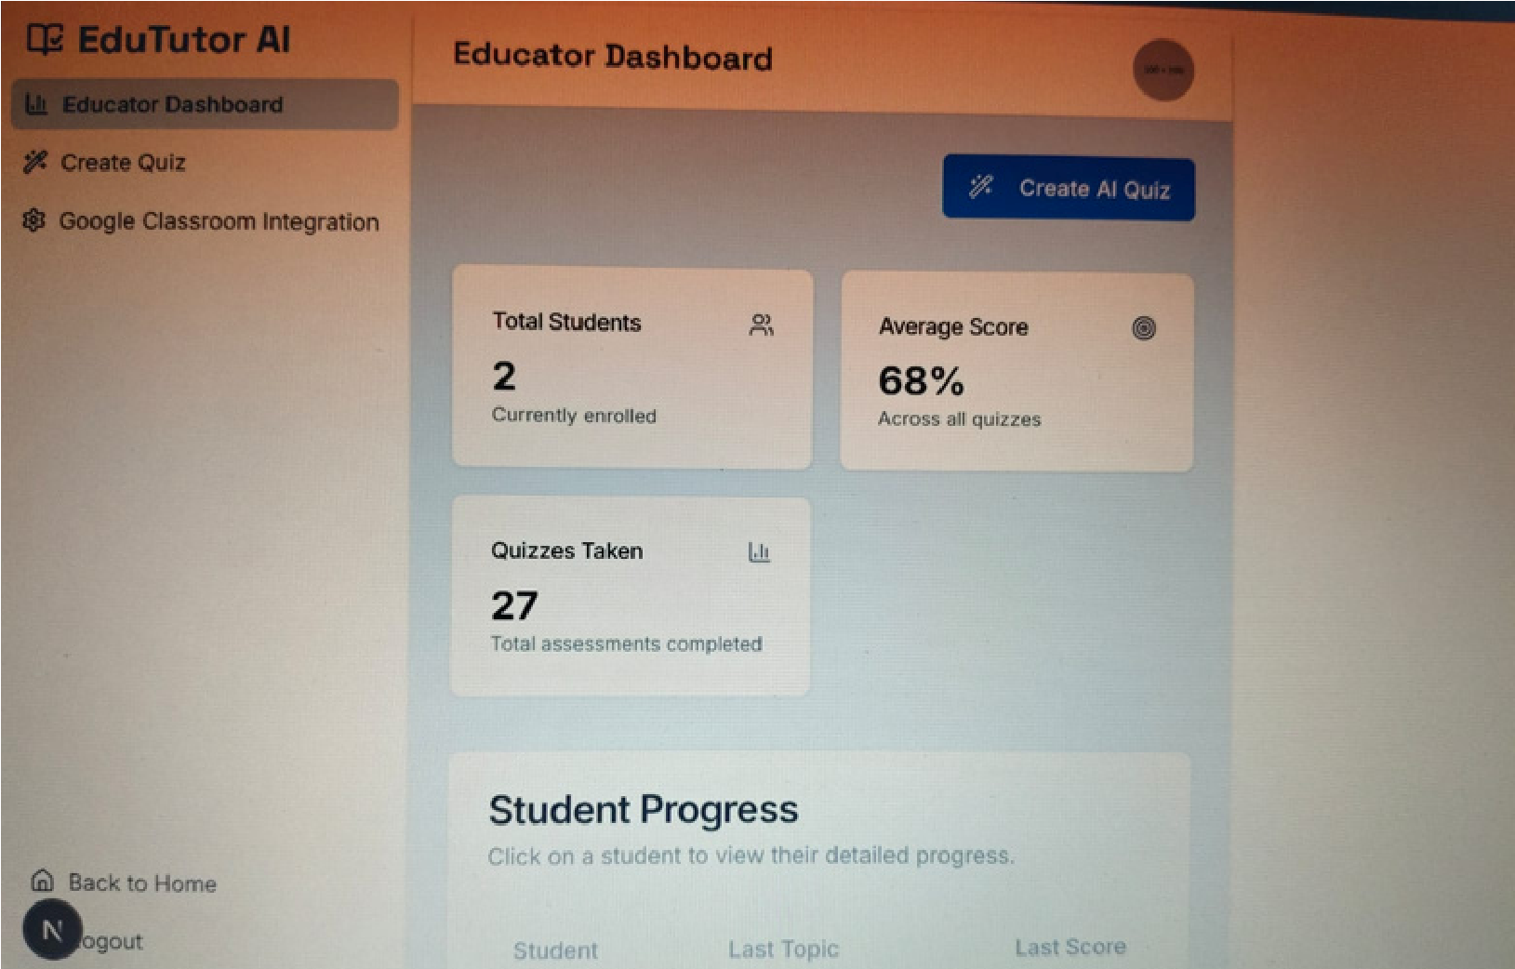

## 8.ADVANTAGES &DISADVANTAGES

**Advantages:**

* Quick and personalized learning
* Minimal setup required
* AI-generated quizzes improve retention **Disadvantages:**
* Dependency on internet and IBM API
* May require fine-tuning for specific subjects

## 9. CONCLUSION

EduTutor AI offers an innovative approach to personalized learning. It bridges the gap between traditional study methods and AI-powered solutions by providing instant explanations and quizzes. The platform enhances the learning process and makes education more interactive and effective.

## 10. FUTURE SCOPE

* Add support for diagram-based explanations
* Include multilingual quiz support
* Integrate with platforms like Google Classroom
* Track student progress and analytics

## 11. APPENDIX

GitHub & Project Demo Link:

https://github.com/vandana9603/edu-tutor.git